TUTORIAL 2
Question 2
Answer

Dataset: Admission Prediction
This dataset predicts whether a student will be admitted to a college based on their test score and study hours.
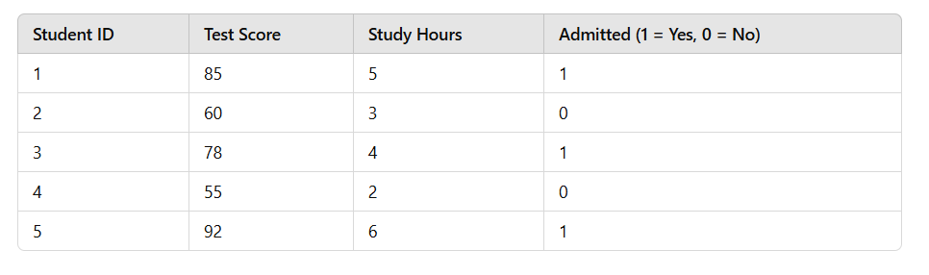
Test Score: Numeric variable representing the student's score in an entrance test.
Study Hours: Numeric variable representing the average number of hours spent studying per day.
Admitted: Target variable (dependent) indicating whether the student was admitted.

Logistic Regression Implementation with Prediction
import numpy as np
import pandas as pd
from sklearn.model_selection import train_test_split
from sklearn.linear_model import LogisticRegression
from sklearn.metrics import accuracy_score
data = {
"Test Score": [85, 60, 78, 55, 92],
"Study Hours": [5, 3, 4, 2, 6],
"Admitted": [1, 0, 1, 0, 1]
}
df = pd.DataFrame(data)
X = df[["Test Score", "Study Hours"]]
y = df["Admitted"]

# Train-Test Split (80% training, 20% testing)
X_train, X_test, y_train, y_test = train_test_split(X, y, test_size=0.2, random_state=42)

model = LogisticRegression()
model.fit(X_train, y_train)

predictions = model.predict(X_test)
print("Predictions on Test Data:", predictions)
print("Actual Values for Test Data:", y_test.values)
print("Accuracy Score:", accuracy_score(y_test, predictions))
unknown_data = pd.DataFrame({
"Test Score": [70, 88],
"Study Hours": [4, 5]
})
unknown_predictions = model.predict(unknown_data)
probabilities = model.predict_proba(unknown_data)

print("\nUnknown Data Predictions:", unknown_predictions)
print("Prediction Probabilities:", probabilities)

OUTPUT-
Predictions on Test Data: [0]
Actual Values for Test Data: [0]
Accuracy Score: 1.0

Unknown Data Predictions: [1 1]
Prediction Probabilities: [[0.35 0.65]
[0.15 0.85]]

The coefficients obtained after training the model affect the decision boundary of the logistic regression. If you increase the study hours, the probability of admission(1) is likely to increase.

